**Install jenkins**

Step 1:- Create Jenkins server.

-Attach admin role to it. An add port 8080 to sg.

-Ssh it .

Step 2:-Install Jenkins

--**[**ec2-user ~]$ sudo yum update –y

--$ sudo wget -O /etc/yum.repos.d/jenkins.repo \

<https://pkg.jenkins.io/redhat-stable/jenkins.repo>

--$ sudo rpm --import <https://pkg.jenkins.io/redhat-stable/jenkins.io-> 2023.key

--$ sudo yum upgrade

--$ sudo dnf install java-17-amazon-corretto -y

--sudo yum install jenkins -y

--$ sudo systemctl enable jenkins

--$ sudo systemctl start jenkins

--$ sudo systemctl status jenkins

Install git.

Step 3:- do vim /etc/sudoers

Add jenkin user to it.

**Jenkins ALL=(ALL) NOPASSWD:ALL**

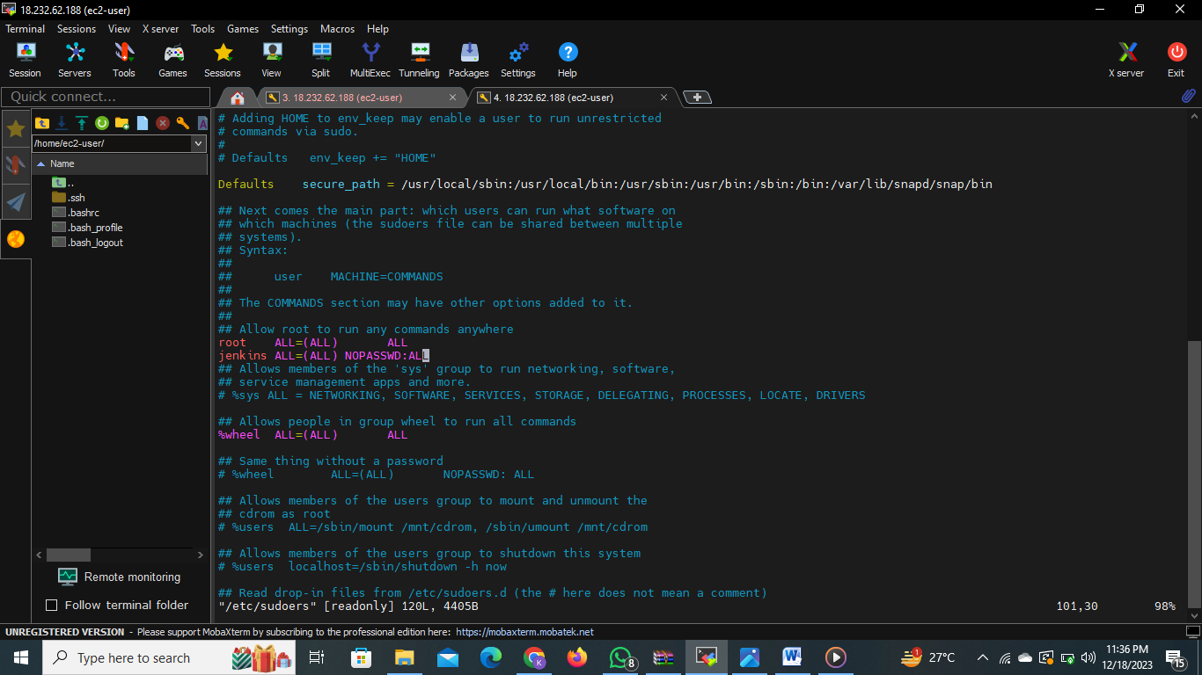

Step 4:- paste ip of instance into web page.

18.232.62.188:8080

Step 5:-start Jenkins

Copy password link is provided by the Jenkins and paste to the server.

Cat (password link),get the password ad paste in the Jenkins.

Step 6:- Create rpo in ecr of aws.

Cdec-repo. Check view push commands.and copy the ien commands and past to pipeline.

stage('docker push ') {

steps {

sh ''' aws ecr get-login-password --region us-east-1 | sudo docker login --username AWS --password-stdin 423513534757.dkr.ecr.us-east-1.amazonaws.com

sudo docker tag tomcat-student 423513534757.dkr.ecr.us-east-1.amazonaws.com/cdec_repo:latest

sudo docker push 423513534757.dkr.ecr.us-east-1.amazonaws.com/cdec_repo:latest'''

}

Step 7:-create new

Select pipeline

Past the following code to script

pipeline {

agent any

stages {

stage('git checkout') {

steps {

git 'https://github.com/Pritam-Khergade/student-ui.git'

}

}

stage('docker install ') {

steps {

sh '''sudo yum install -y docker

sudo systemctl start docker

sudo systemctl enable docker '''

}

}

stage('docker build ') {

steps {

sh 'sudo docker build -t tomcat-student .'

}

}

stage('docker push ') {

steps {

sh ''' aws ecr get-login-password --region us-east-1 | sudo docker login --username AWS --password-stdin 423513534757.dkr.ecr.us-east-1.amazonaws.com

sudo docker tag tomcat-student 423513534757.dkr.ecr.us-east-1.amazonaws.com/cdec_repo:latest

sudo docker push 423513534757.dkr.ecr.us-east-1.amazonaws.com/cdec_repo:latest'''

}

}

}

}

build now

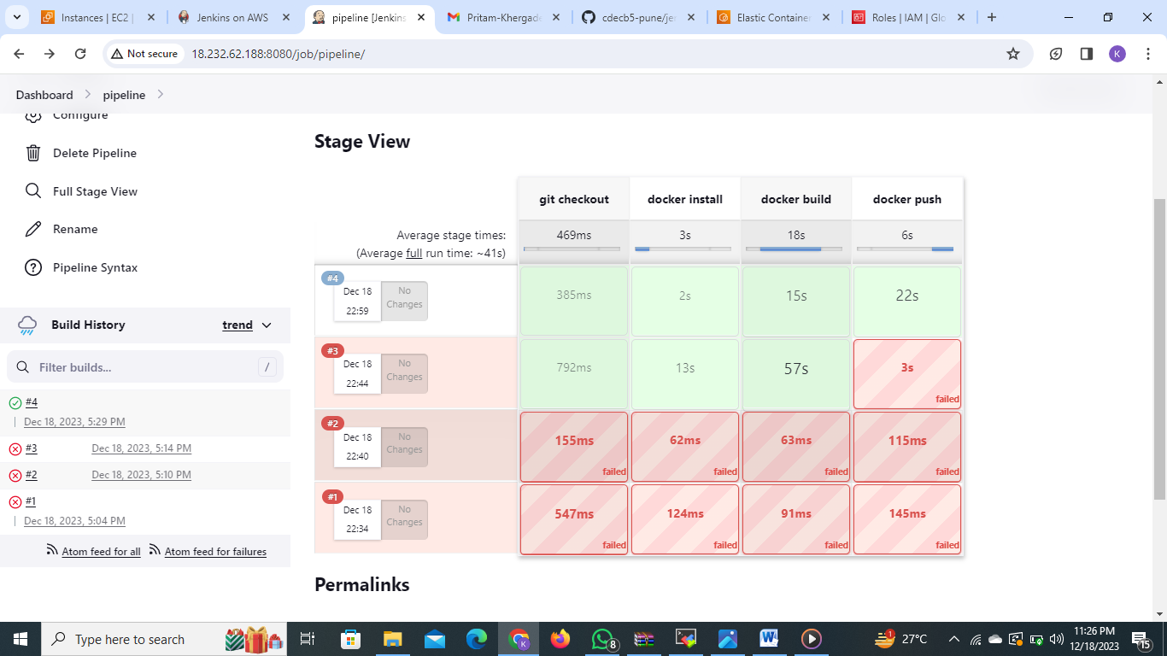

Image is stored in the repository cdec-repo

